**Big Data and Analytics**

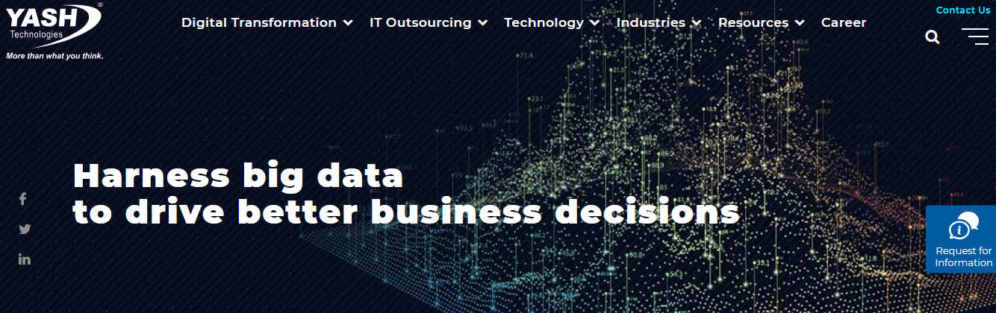

Text to be replaced

**Transform Your Enterprise with the Power of Big Data Analytics**

Next>>

**Big data analytics** is playing a major role in making organizations cleverer and more effective. Consequently, it is hard to imagine a successful business system or application which is not providing bits of knowledge to its clients. We have grown a deep understanding of **Big Data Analytics** advancements/systems and business spaces to enable you to give basic bits of knowledge from disparate data sources.

We worked in various domains and which led us to rapidly connect with business drivers behind the big data implementations and allowed us to help you in the process of use-case discovery, solution outline, and execution plan/guide. Our team bring a comprehensive view of how **big data and advanced analytics** can help enhance how you use your strategic data assets.

Next>>

Why Work with Nunc?

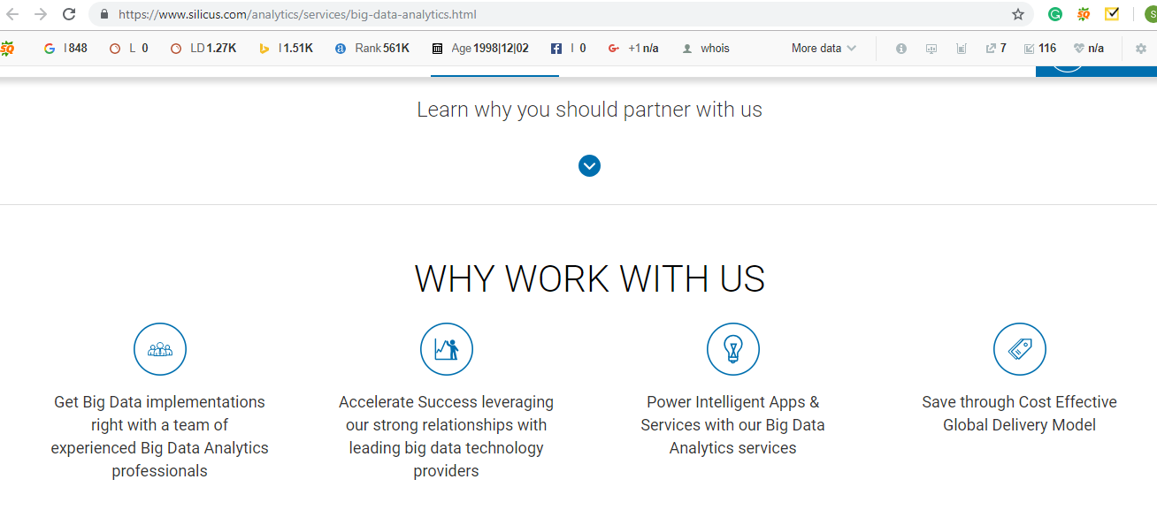

Text to be used:

1. We have a team of experienced Big Data Analytics professionals who help you to get Big Data implementations
2. Accelerate Success leveraging our robust relationships with top big data technology providers
3. Power Intelligent Apps & Services with our Big Data Analytics services
4. Save through Cost Effective Global Delivery Model

**NUNC Big data services**

We implement a high knowledge base, for offering data services and our expert team provides your business with the most suitable data model. Analytic services provide solutions that can help organizations capitalize on the transforming potential of Big Data and derive deliverable insights from their data.  
  
Our business domain expertise coupled with capable technical competencies enable us to define a Big Data strategy for your organization, integrate Big Data into your overall IT roadmap, architect and implement a solution and empower your business.

**Next>>**

**Need For Expert Data Analysis:**

* Mitigate the data loss incurred by the company, by offering quality data resources and adequate support
* Improving the sales sector of a company by supplying the best in market high quality data techniques
* To improvise the levels of customers satisfaction by conducting data analysis surveys

**Next>>**

